1st Payroll of the New School Year

Part 2

Presented by ESC, Region 14

March, 2020

Reminders:
- Budget must be initiated. You must have completed Part 1, Budget-1st Payroll of the New Year before beginning this document.

- The following HR pages are shared between Current and Next Year:
  - Tables > District HR Options
  - Tables > Credentials
  - Tables > Tax/Deductions
  - Tables > Bank Codes
  - Maint > Staff Demo
  - Maint > Staff Job / Pay Data > Employment and Info Tab

- Helpful data to gather:
- New Salary Scales
- Next Year Calendars
- Payroll Calendars
- Accrual Calendars from Current Year (Codes & Workdays)
- List of Resignations and New Hires
- Campus level changes
- Distribution Changes (based on schedule)
- Extra Duty Scales and Assignments

Log into Human Resources – Next Year Pay Frequency

_____45. Build or Update Salary Tables as needed from Tables > Salaries. Review each tab and update.
Local Annual, Hourly/Daily: Modifications can be made by percent or dollar amount to all or a select pay grade/step, or may be adjusted individually. To see the change before saving, enter the desired change and click on the Default button. The original annual amount shows in the Annual Amt column, the percent or dollar increase, and then the New Amount. To activate the increase, you must Save. Decreases in salaries may be made using a negative percent or dollar amount.

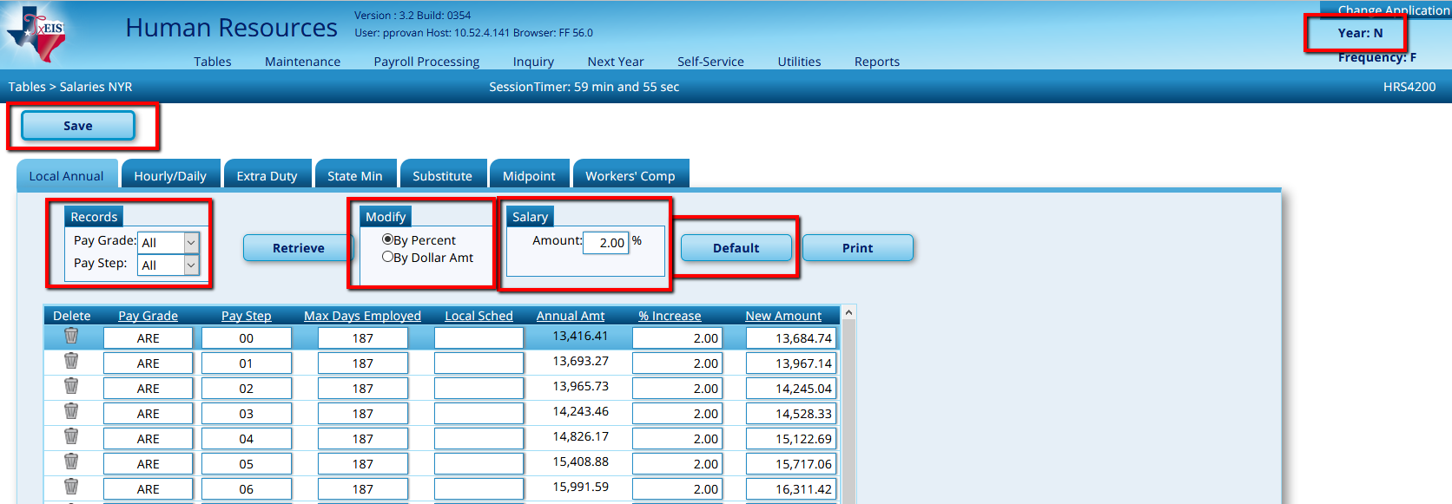

Original Amount New Amount

Extra Duties: See separate Extra Duty Document, but you can update table now.

Add or modify as needed
- Adding account Codes is optional, but will simplify when adding to employee. Portions of the account codes can be masked.
- Expense 373 flag acts differently depending on whether the Extra Duty is a G-Type or S-Type:
  - G-Type:
Amount is automatically included in Stat Min Calculations. Selecting Y - means the account code will be charged for Stat Min.
Selecting N - means the account code will not be charged.
  - S-Type:
Selecting Y means the amount will be included in Stat Min Calculations and charged to the account code.
Selecting N – means the amount is excluded from Stat Min calculations.
- TRS Member Position: Select the Member Position associated with the Extra Duty. If no Position Code is selected, TxEIS assigns Position Code 03 Support Services automatically.

Note: If the Extra Duty is included in State Min Calculations the Position Code must match the employee’s Primary Position Code. This may require additional Extra Duty Codes. For example: If you pay $500 stipend to employee’s with a Master’s Degree, you may need a Master’s Degree Stipend for Position Code 01 – Administrators, 02 – Teachers and 05- for Counselors, etc…

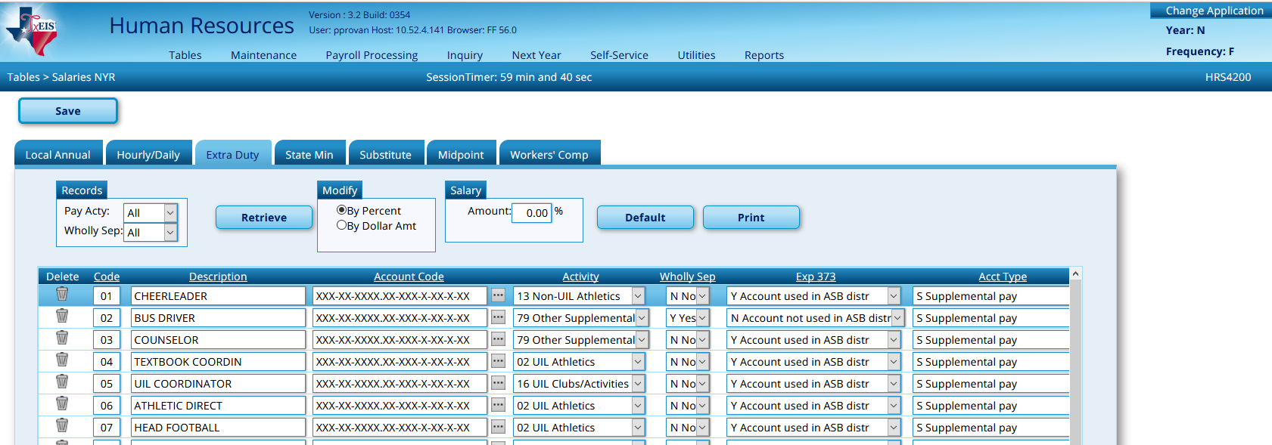

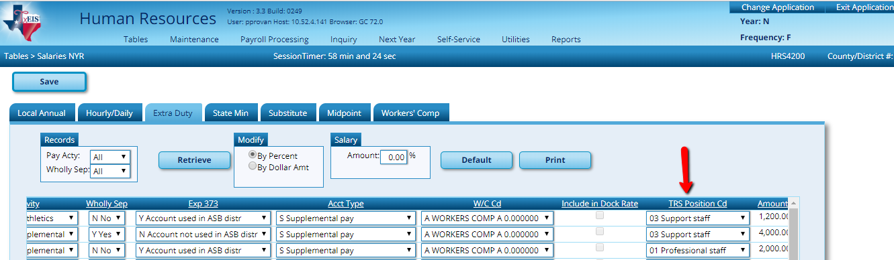

Substitute: Also can be updated en masse by percent or dollar amount or individually. Ensure that the amount displayed here meets or exceeds minimum wage. The minimum for 7.5 hours per day is $ 54.38 (round to $55.00). The minimum for 8 hours per day is $ 58.00.

Note: The current federal minimum wage is $ 7.25 per hour. (Source: https://www.dol.gov/whd/minwage/america.htm
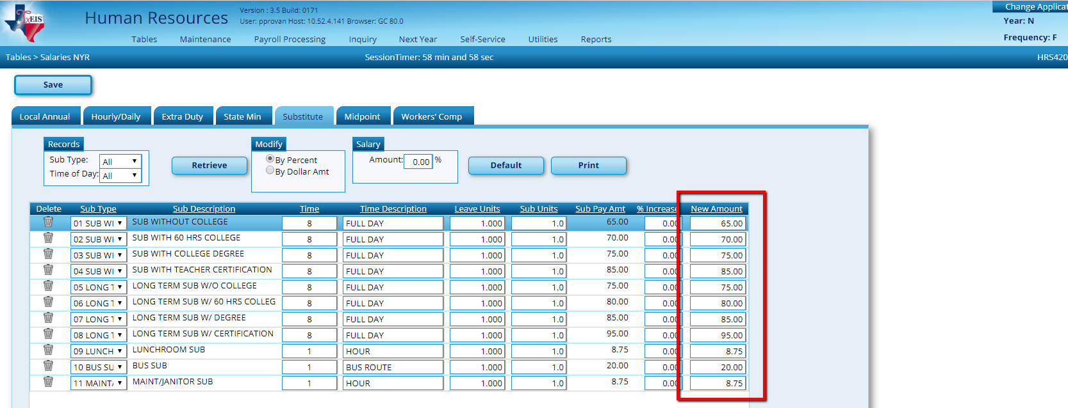

_____46. Update the TRS Rates for School Year 2021 from Tables > Tax/Deductions > TRS Rates as needed.

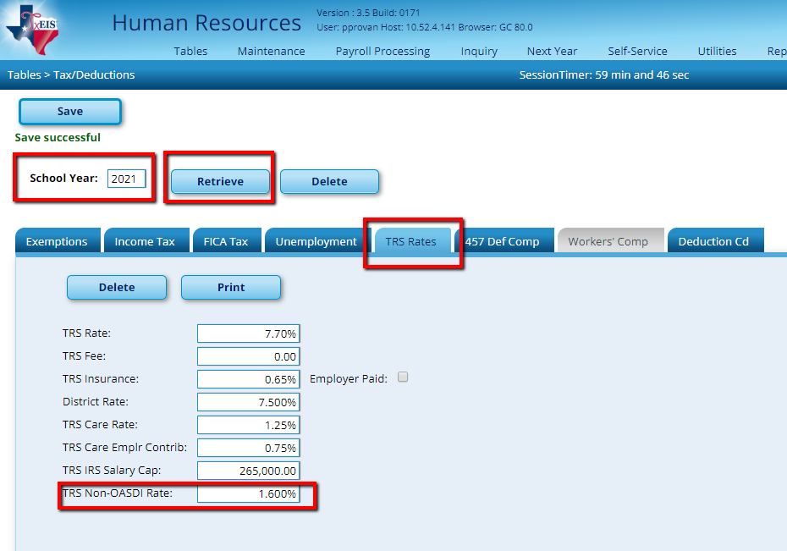

_____47. Review and update Deductions from Tables > Tax/Deductions as needed.

Deduction Codes: If you have new deduction codes, enter them here.

Table > Tax/Deductions > Deduction Cd tab

Select the Deduct Chk box to have the system create a deduction check to be printed during each payroll. Selecting the Wire box instead will allow you to create the wire automatically in the Transfer Transaction utility during payroll.

Assign an Extract Deduction Code ONLY if the deduction will be managed by your third party administration.

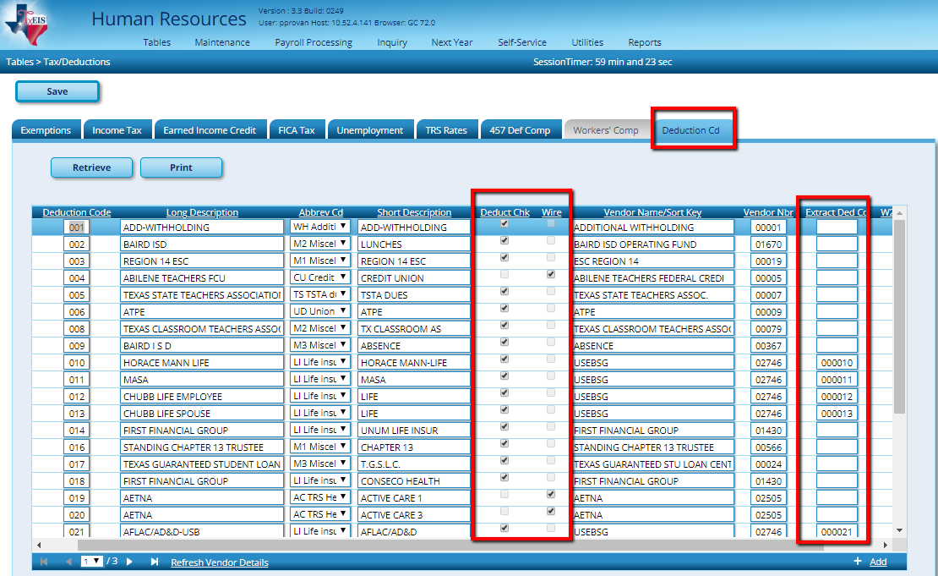
Abbreviation Codes are shown below along with the object code TxEIS automatically sends the liability to.

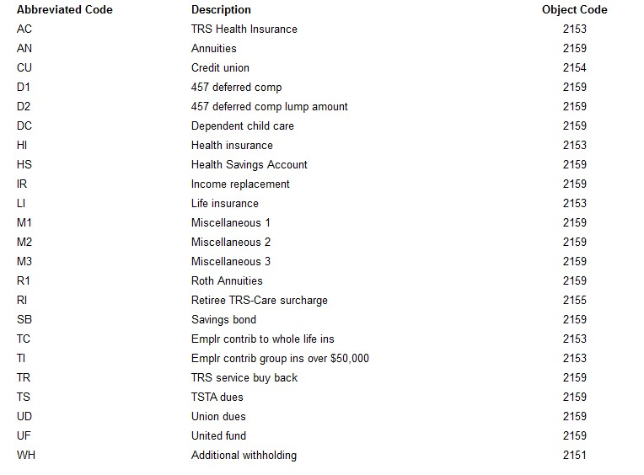

_____48. Review and update the Job Code table from Tables > Job /Contract > Job Codes.
- In the FSP column, select the appropriate Class Code for classroom teachers, nurses, counselors, librarians, and administrators. If none of the class codes are appropriate for the job, leave the class code blank.
- Add Accrual Codes to appropriate Job Codes. Doing so will automatically populate the Accrual Code into the Job Info screen as the Job Code is added.
- Add Account Codes to Job Codes. Mask areas as desired. Doing so will automatically populate the account code in the Distribution screen as a Job Code is added.

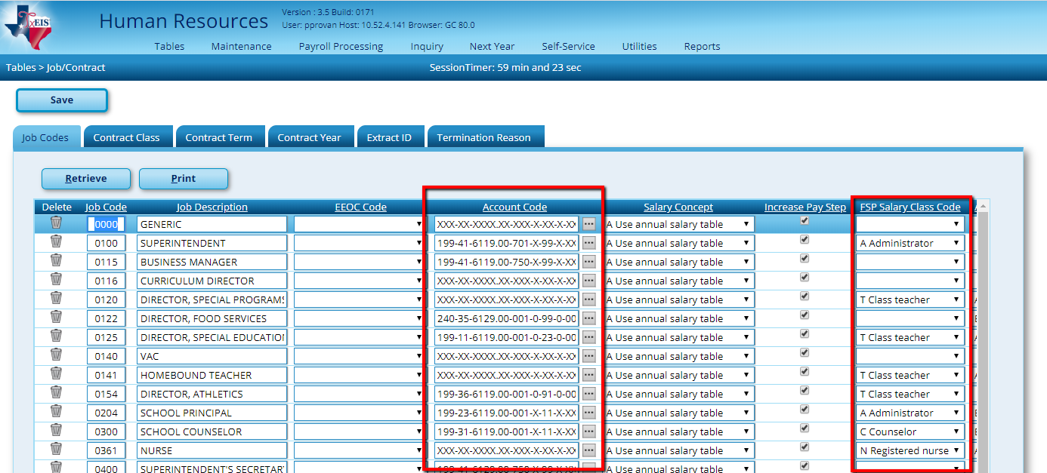

_____49. Review and update bank information from Tables > Bank Codes > Bank Codes tab.

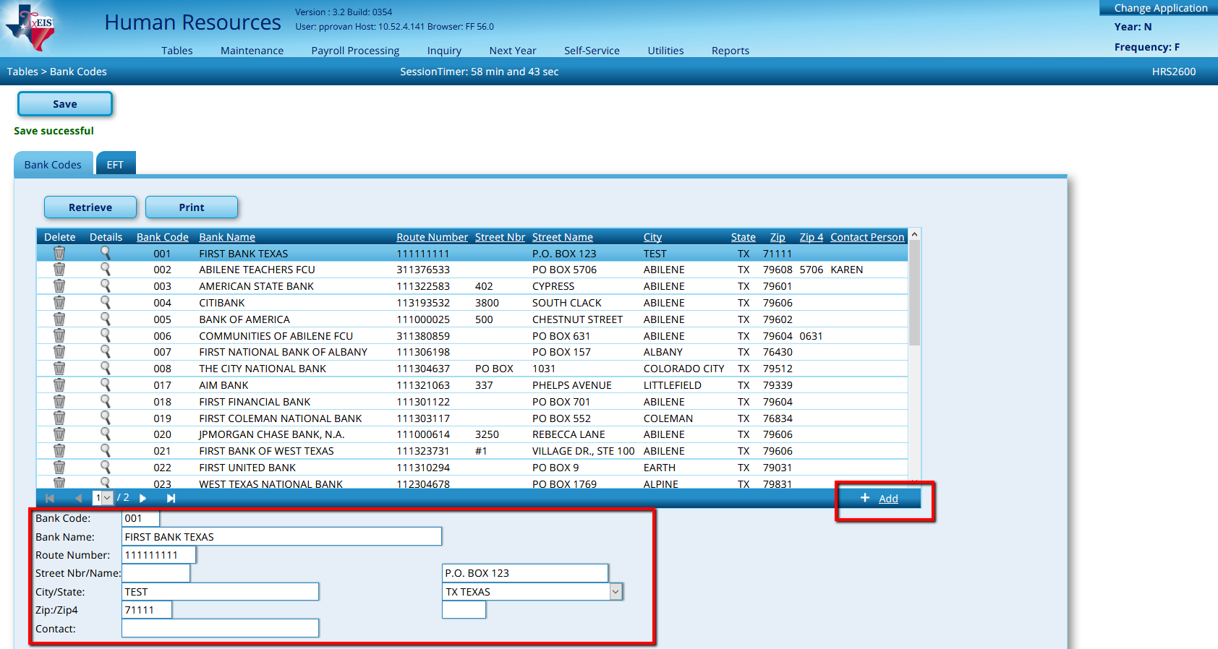

_____50. Review and update School and Accrual Calendars from Tables > Workday Calendars.

School Calendar: Calendar Code and Descriptions were copied from the current year, but you’ll need to set each calendar for 2020-2021. Click the spyglass in front of the calendar code and enter the start year and month, then Set Calendar.

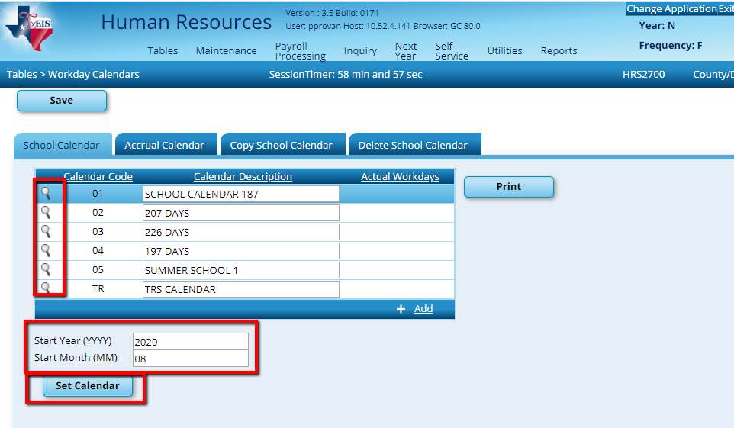

If you need to Add a Calendar, click the +Add and enter the
- Calendar Code,
- Calendar Description,
- Click the Spyglass for the Start Year and Star Month to appear
- Start Year
- Start Month
- Click Set Calendar.

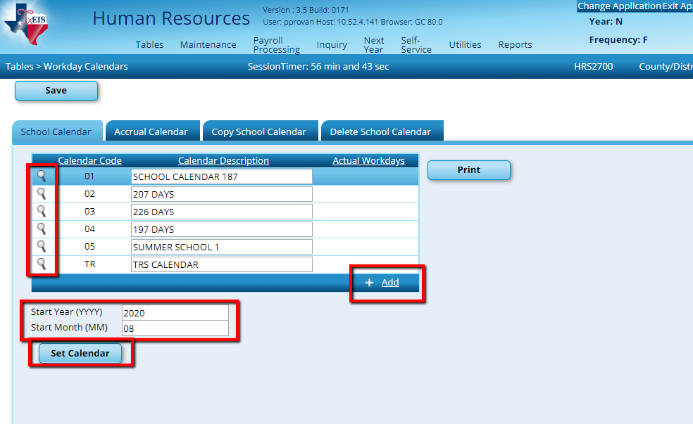

Select the date that represents the beginning of this school calendar. A box will display around the number. Click the Legend for the ‘Begin Date’ or ‘Begin Date In-Service’ link to the right. The date will turn turquoise or green to match the legend. Continue entering other dates as appropriate. Multiple dates can be selected at once. Save all changes. This will need to be repeated for each calendar or copy similar calendars and modify as needed.

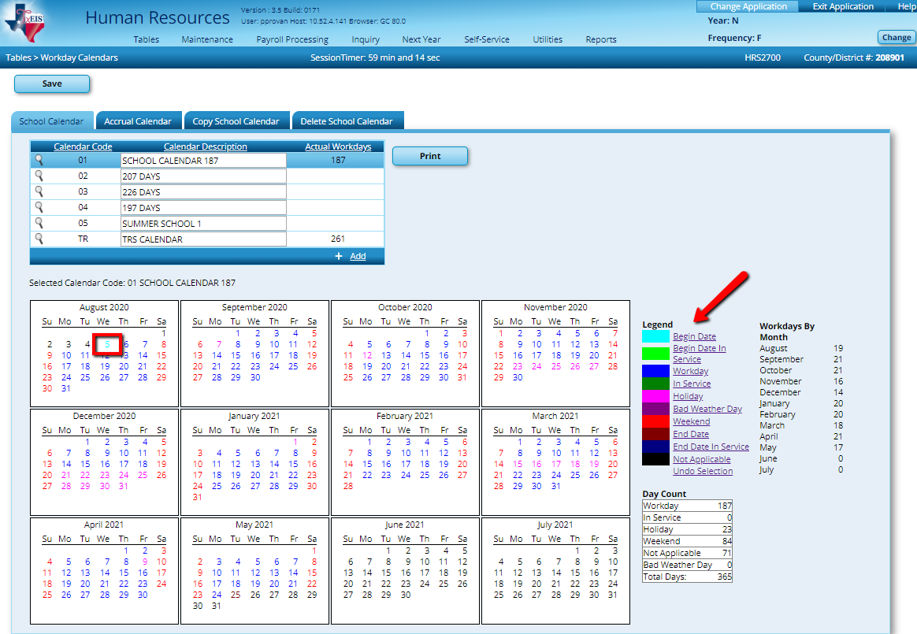

Once one calendar is saved, you can copy that calendar, then simply make adjustments as needed rather than entering everything from scratch again. On the Copy School Calendar tab, select Frequency F and the Calendar Code. (Calendars that have been saved have a red box area.) Select the calendar (s) you want these dates copied to and Save.

Note: This will work for the calendars with the Same Begin Month and End Month. In this example we selected 197-day calendar to show you what it will look like once you select a calendar.
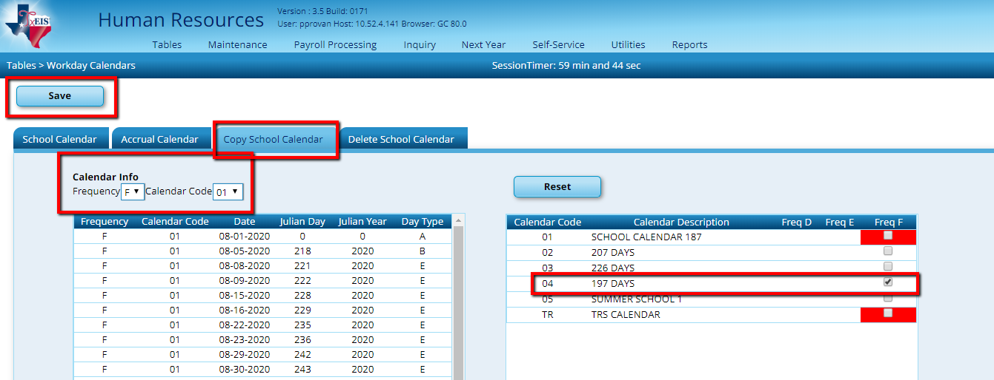
Copies to the One’s Checked.

Copies From

When you go back to the School Calendar tab, you’ll see that the same dates have been set to the selected calendar (s). Use the spyglass to open each calendar and make adjustments.

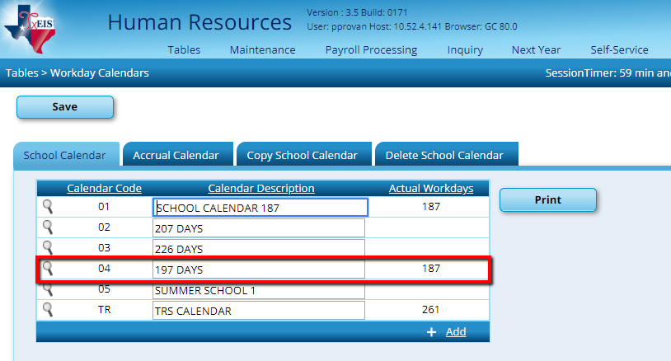

Reminder: The TR Calendar should always start with month 09. This calendar will always run from Sept 1 (or the first day of work in September) – August 31.

Tables > Workday Calendars

Accrual Calendar: Use the spyglass to open each Accrual Calendar and set the pay dates. Calendars for employees who have August Accruals calculated should begin with 8/31, then have a Paydate for every regular paydate from Sept thru Aug. These dates need to match the pay dates that will be entered in the Pay Dates table exactly or you will get errors in payroll and on the Accrual Variance Extract (with the exception of 8/31).

Note: You can print off the School Calendars and this will give you the days worked for the month.
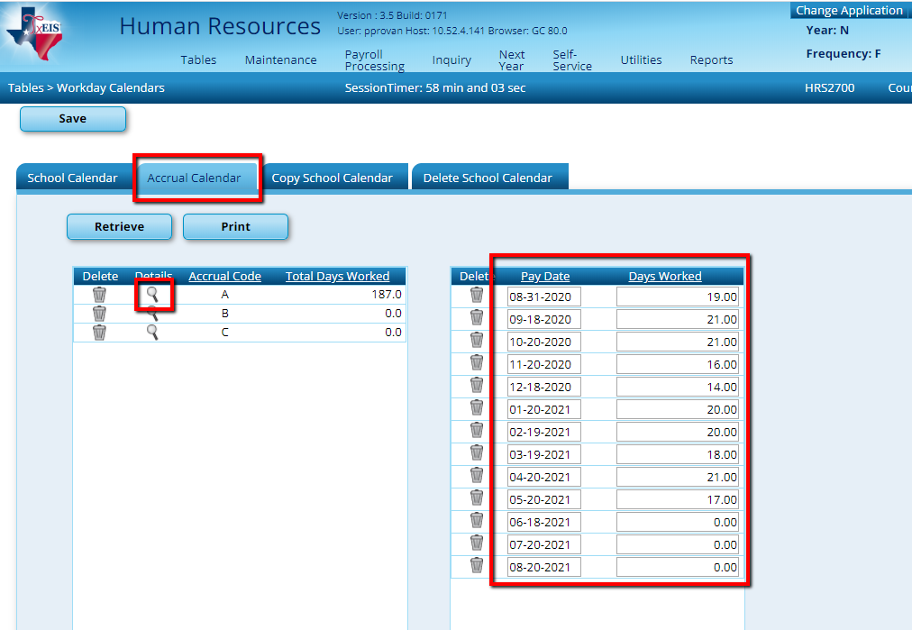
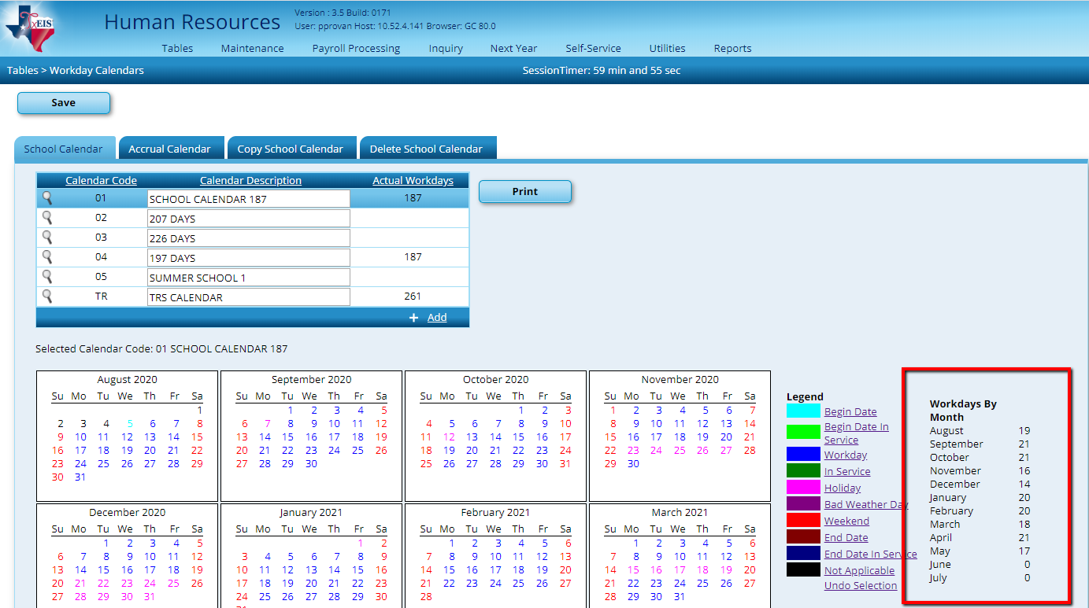

_____51. Mass Update Employee data. From Utilities > Mass Update, use each tab to update data for groups of employees.

Deductions tab: Select the Method desired and make adjustments to deduction records for next year. Remember that some deductions may be automatically updated through your Third Party Benefits Interface file. Common tasks include:

Change Existing Code and Amounts to Another: If you have changed from one insurance provider to another, this will allow you to change everyone over to the new company at once.

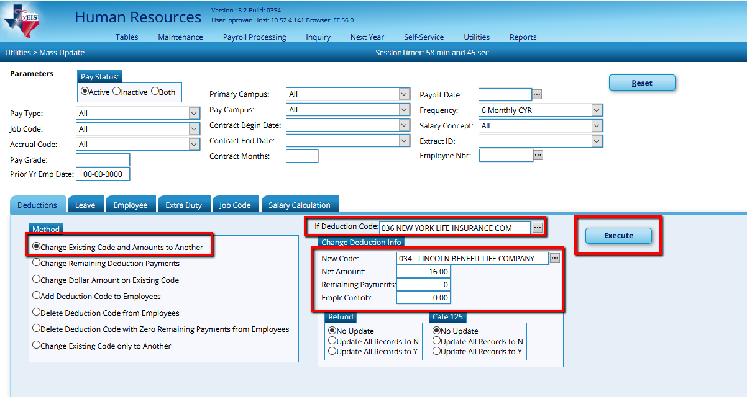

Change Dollar Amount on Existing Code: This is common when insurance premiums change. This method will allow you to choose the applicable deduction code, then change the Net Amount (Employee amount) and/or Employer Contribution from one amount to a new amount.

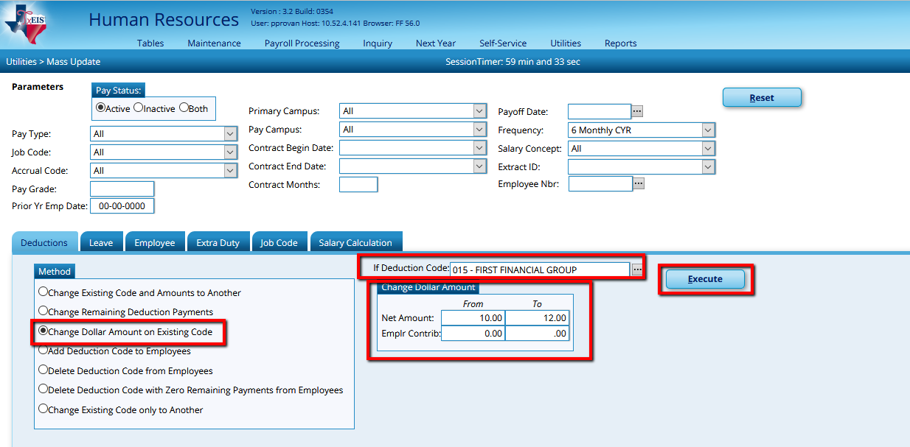

Add a new Deduction Code to Employees: Works great if you are now offering a new benefit such as pre-paid legal. Once the new deduction code has been entered into the table, select the new code, the Net Amount (Employee portion), the Remaining Payments, and the Employer Contribution. Check if Cafe125 is applicable and Execute.

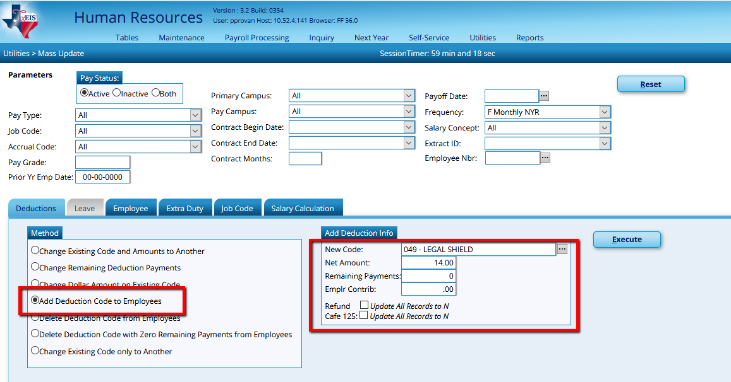

Delete Deduction Code from Employees: If you will no longer offer a particular deduction and want to delete that code from all employees, this is your best bet. Simply check applicable deductions and Execute.

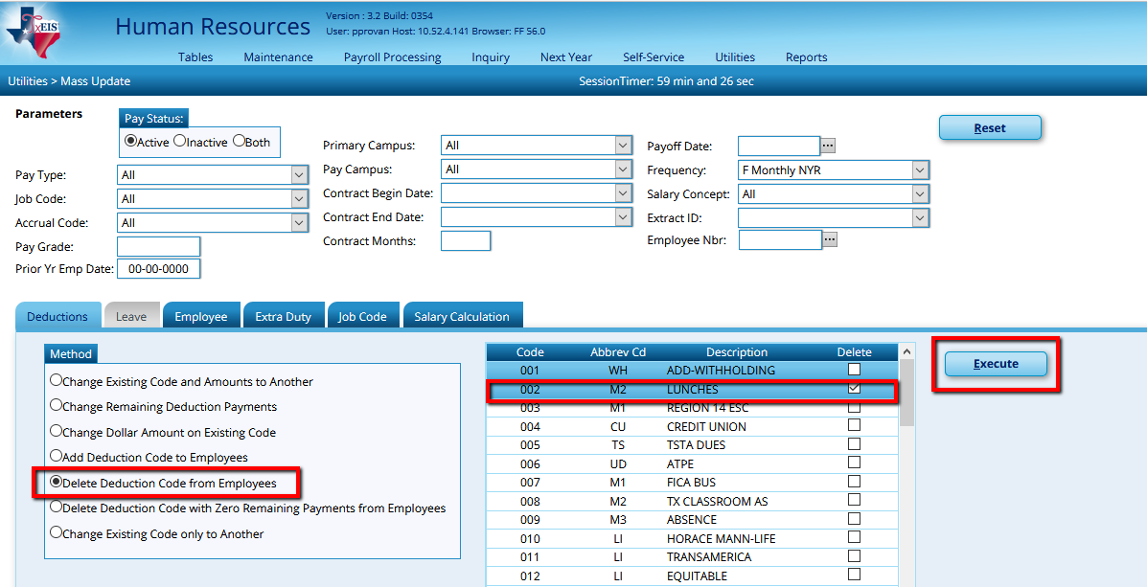

Employee tab: We recommend you update information on this tab by Extract ID and utilize the Reset and Increment areas primarily. Our examples will focus on regular 10 month employees. You will need to repeat these processes for each group of employees. In addition, be aware that employees who do not have Extract IDs will need to be updated individually in their maintenance screens. Most of the information will be the same for all employees in the group. If you have exceptions, we recommend you mass update everyone, then go back and change applicable information on those exceptions. If you have multiple pay frequencies, you will need to repeat for each frequency as well.

In the Parameters section, select the Extract ID desired. Update information for the group by checking the box 1st then enter the information. In the Reset area we typically update the following:
- Local Contract Days
- Payoff Date
- Number of Annual Payments
- Number of Remaining Payments
- Workers Comp Annual Payments (if applicable)
- Workers Comp Remaining Payments (if applicable)

- Calendar
- Contract Begin Date
- Contract End Date
- Number of Days Employed
- Number of Months in Contract
- Contract Days (Refers to the
contract TRS expects for this
employee type)

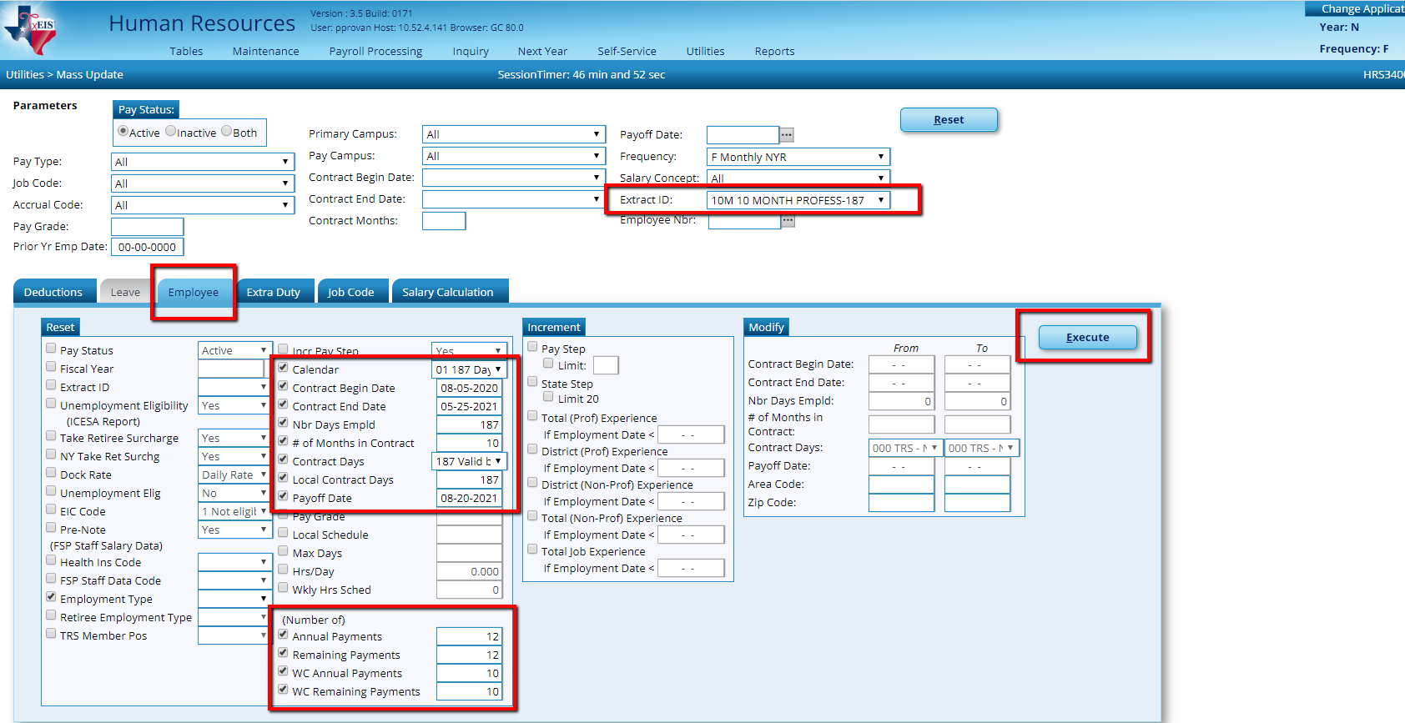
Will need to complete this step multiple times until you have Executed all Extract ID’S.

Execute. At the preview, select Process.

Repeat this process for each Extract ID. Once completed, run a User Created Report to verify that all employees were updated. From Reports > User Created Reports > HR Reports, select the following:

• Employee Number | • Nbr of Annual Payments
• First Name | • Remaining Payments
• Last Name | • Nbr of month in Contract
• Extract ID | • Nbr Days in Contract
• Calendar Code | • Workers’ Comp Annual
• Contract Begin Date | • Workers’ Comp Remain
• Contract End Date | • Payoff Date
• Nbr Days Employed | • Fscl Yr (Updated in Part 1)
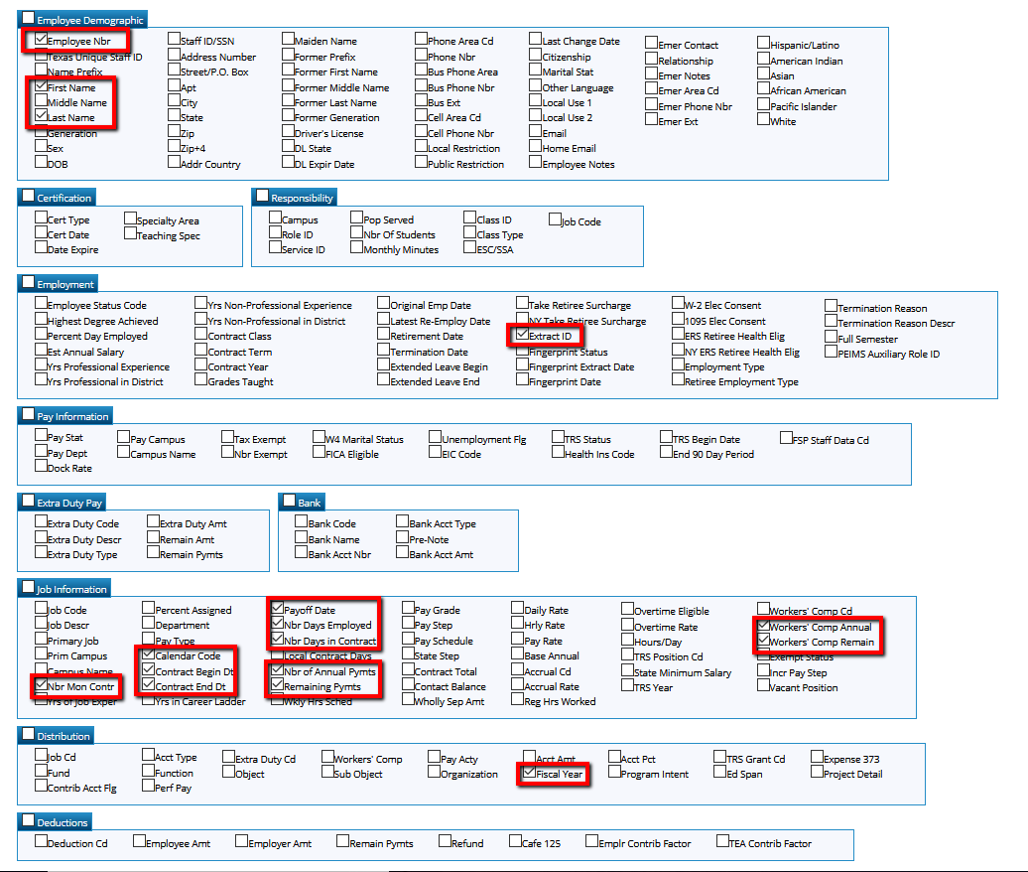

Sort the resulting report by Extract ID to make review easier by selecting the Sort/Filter button.

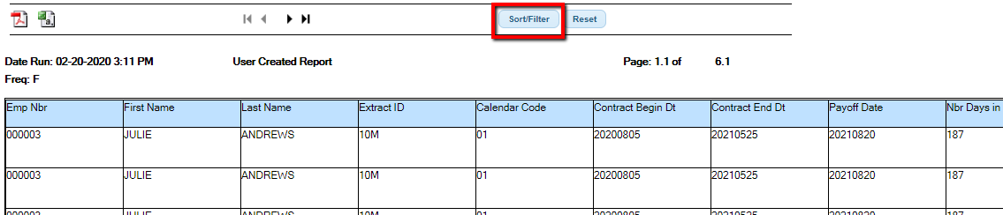

In the popup box, Move the Extract ID to the right and click OK.

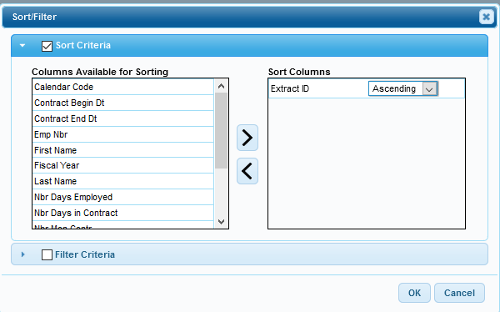

Select the pdf or the csv to print.

The resulting report will group employees with the same Extract ID together. Review each column to ensure accurate information. If information is missing or incorrect, update individually in each employee’s maintenance screen.

Utilities > Mass Update cont.

Extra Duty tab: Allows you to update Extra Duty information if you utilize Extra Duty tables. Similar to the Deductions tab, employees can easily be updated en masse Changing one Extra Duty Code to Another, Changing Existing Extra Duty Code Information, and Adding or Deleting Extra Duty Codes. This is the easiest way to update Extra Duties. It is easy to get “caught in a loop” updating Extra Duties in individual Employee’s screens. For more detailed information, refer to the Extra Duty document.

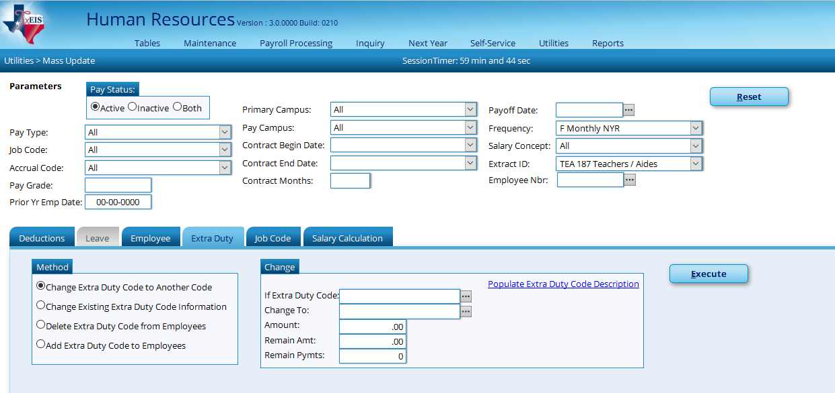

Utilities > Mass Update cont.

Job Code tab: Used to change one Job Code to Another. The screen is easily understood.

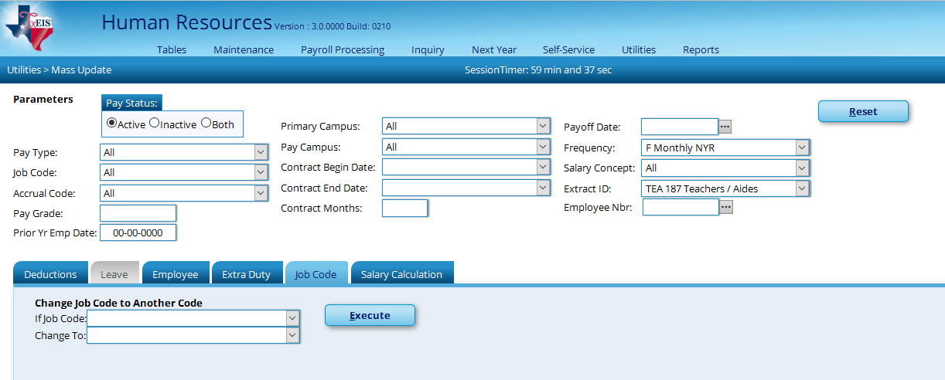

_____52. Review employee payroll information from Reports > HR Reports > Payroll Information Reports > HRS 6400 (Salary Verification Report.)

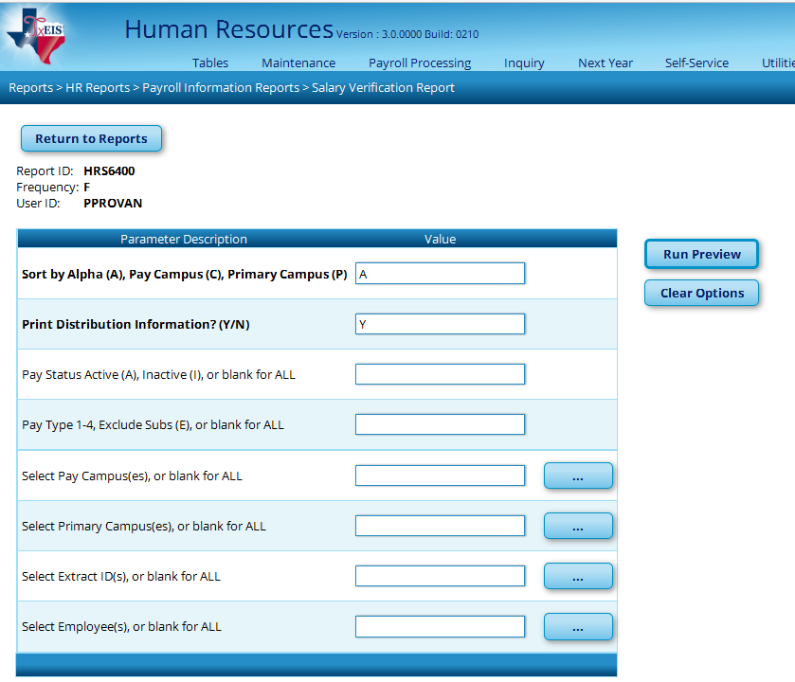

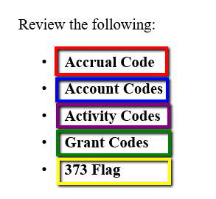

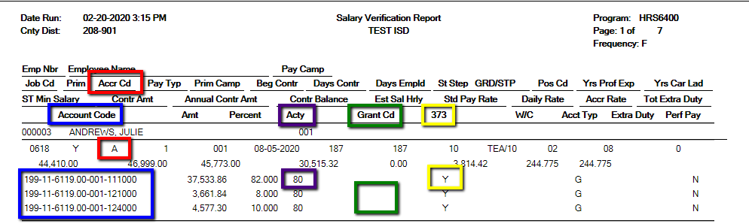

Changes required after this review should be done on each employee’s Job Info. and /or Distribution screens.

Note: If a Grant Code is missing or incorrect, the change will have to be made in Current Year Payroll. The TRS Grant Code table is unavailable in Next Year Payroll. If you find this is the case with you district, please contact a Region 14 TxEIS Business Consultant for assistance as this may mean adjustments to your Current Year TEAM reporting.

_____53. Add any new employees and update employees who were not updated during the previous steps. Keep the following in mind as you update:

- Staff Demo and the Employment Info tab from Maintenance > Staff Job/Pay Data, are shared with Current Year Payroll.
- Pay Info, Job Info, Distributions, and Deductions are not shared with Current Year Payroll.
- The exception to these are those areas where you are asked whether you want to change Current Year as well such as Bank Info, W-4 status, exemptions, etc…

Note: Consider building one or more Master Substitutes with the total salary you want budgeted for the district, campus, etc… so TxEIS will calculate and budget for benefits as well.

_____54. Review FICA Eligibility, W-4 Status, and FSP Staff Salary Data for accuracy. A User Created report is recommended.

_____55. Verify Salary rates will pay contracts fully with the Contract Variance Report from Reports > HR Reports > Payroll Information Reports > Report HRS6050 – Contract Balance Variance Report (HRS6050).
Use $ 0 as the Maximum Acceptable Difference. Most contracts will show a variance of a few cents due to rounding. Contracts off by more than a few cents need to be reviewed.

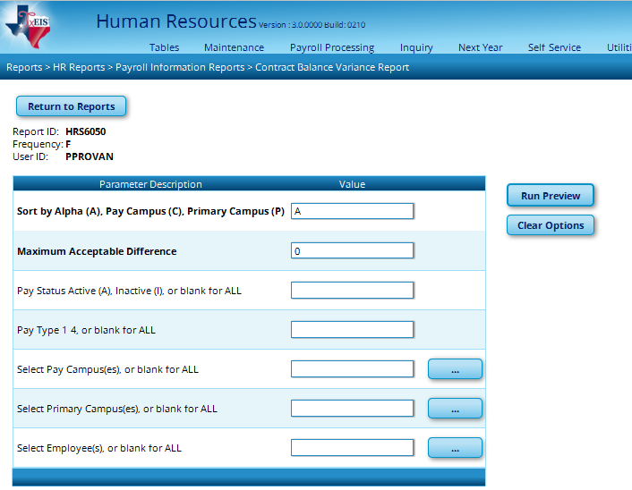

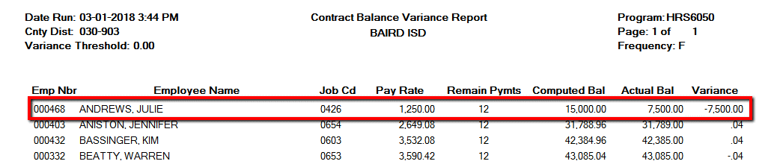

_____56. Run a Pre-Edit. The Pre-Edit Payroll Data utility enables you to process a ‘test payroll’ excluding transmittals and leave. From Utilities > Pre-Edit Payroll Data, choose the August Pay Date and Execute. Review the Error Listing to help ensure all issues are resolved before interfacing to budget.

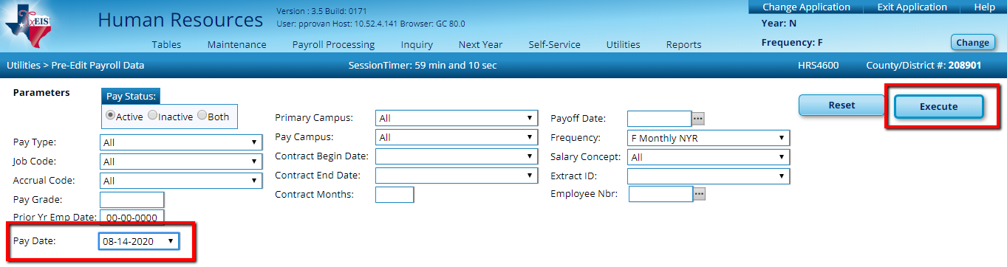
_____57. Perform Salary Calculations for Employees tied to Salary Tables. From Utilities > Mass Update > Salary Calculation tab, select a Salary Concept in the parameters. Select the radio button for Salary. If appropriate check to Apply Percent of Day Employed to Salary Amount. Execute.

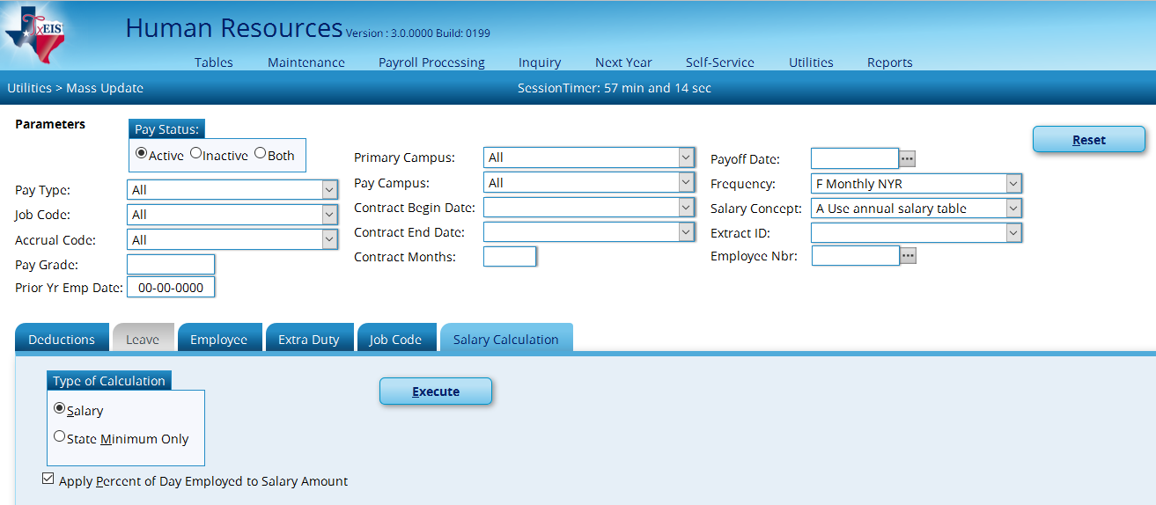

An Error Listing will display like a preview. Any employee listed on the Error Listing will not update. Ensure that those listed are employees who should not be tied to a salary table. If employees are listed who should be tied to a salary table, review the error message to determine the issue. We recommend you Cancel and fix any unwanted errors before proceeding. Once Error Listing is as you wish, Process.

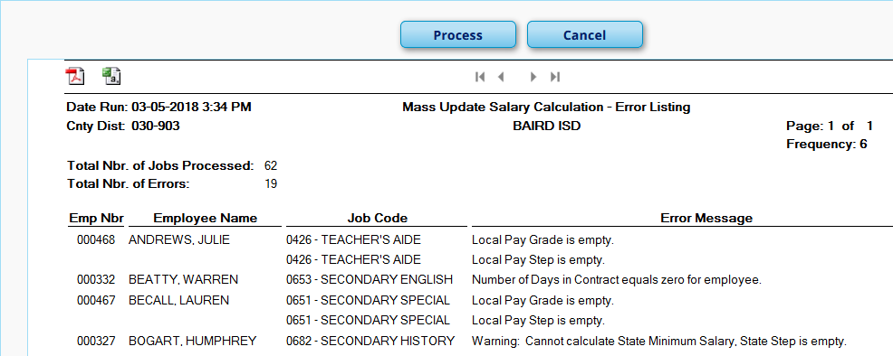

_____58. Unemployment: There are two options for budgeting for Unemployment: allowing TxEIS to calculate for each employee or manually entering an amount in budget. To have TxEIS calculate, set Employer Type to
Tables > Tax/Deductions > Unemployment

T-Taxable, enter Unemployment Rate and Save for Calendar Year 2020,

Taxable
Employers report employee gross wages each quarter and pay taxes on the first $9,000 per employee, per year. In most cases, all wages must be reported.

https://twc.texas.gov/businesses/reporting-determining-taxable-wages

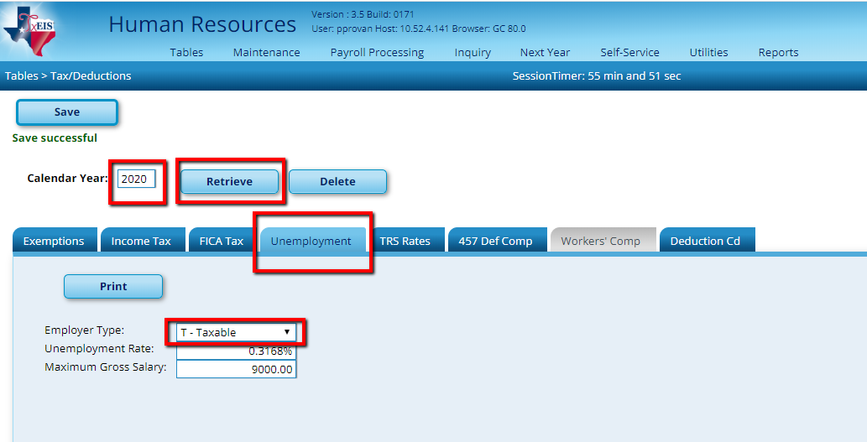
You will get the Unemployment Rate from your Insurance Carrier. TxEIS will calculate Unemployment and send that amount to the Budget Application.

or Employer Type to Reimbursable and enter an amount manually in Budget if preferred.

Reimbursable

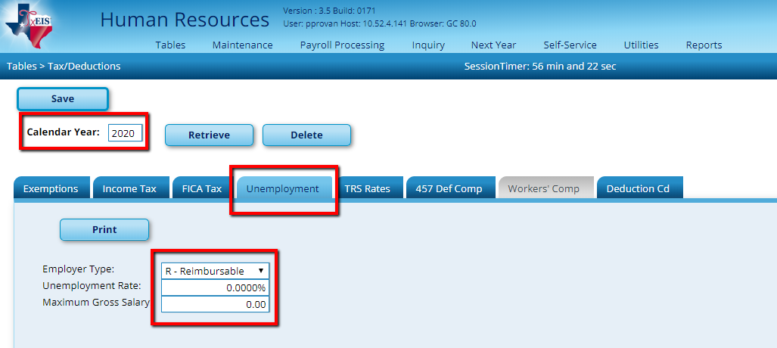
You will leave the Unemployment Rate blank and you will need to manually enter a budget amount in the Budget Application.

Note: This table is shared between Current and NY Payroll. If you currently have this set to Reimbursable in Current Year Payroll, use caution when budgeting.
In the Maximum Gross Salary field, type the maximum amount of an employee salary on which unemployment is calculated.
According to the Federal Unemployment Act, each state must set a taxable wage base of at least $7000. Texas has adopted a base of $9000.

Entering a salary of $9000 in the Maximum Gross Salary Field means that Unemployment will calculate until an employee earns $9000 and then discontinue for the remainder of the calendar year.

Points to consider if you want TxEIS to calculate Unemployment:

- You will need to choose for the Employer Type: Taxable.
- Your Unemployment carrier will provide you with the Unemployment Rate for your district.
- You should consider the trend for Unemployment costs over the past few years to determine the amount that is prudent to budget.
- You still have the ability to manually budget and pay without having Unemployment calculated and posted by the payroll process. If that is your preference, select Reimbursable as the Employer Type and do not enter a rate of max Gross Salary.

Note: For TxEIS to accurately calculate unemployment, for each applicable employee, the Unemployment boxes must also be checked on the Employment Info screen and the Unemployment Eligible box checked on the Pay Info tab for Unemployment amounts to be calculated properly. Human Resources > Maintenance > Staff Job/Pay Data

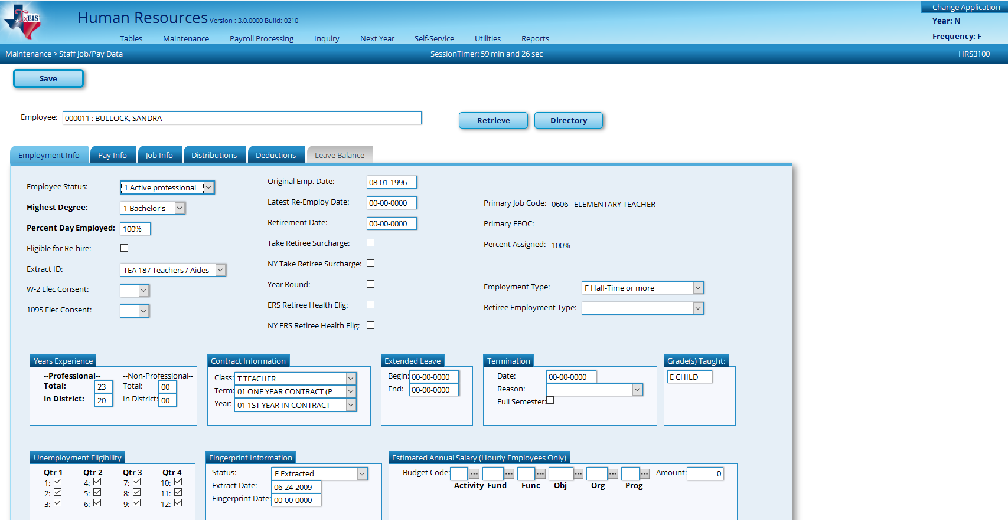

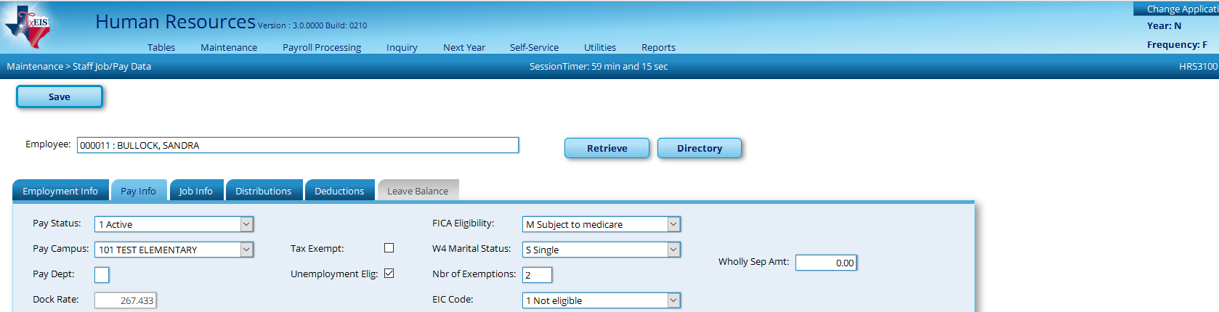

_____59. Extract Next Year Payroll Information to Budget.

NOTE: Steps 59-61 are repeating steps. You will Interface Next Year Payroll to Budget several times during this entire process.

From Next Year > Interface NY Payroll to NY Budget > Extract Payroll Account Codes Tab, enter your TRS On Behalf Expenditure Account, enter the Starting Accounting Period for the Finance Fiscal Year, and move all employees to the right and Run.
Enter account code used during Payroll Process.

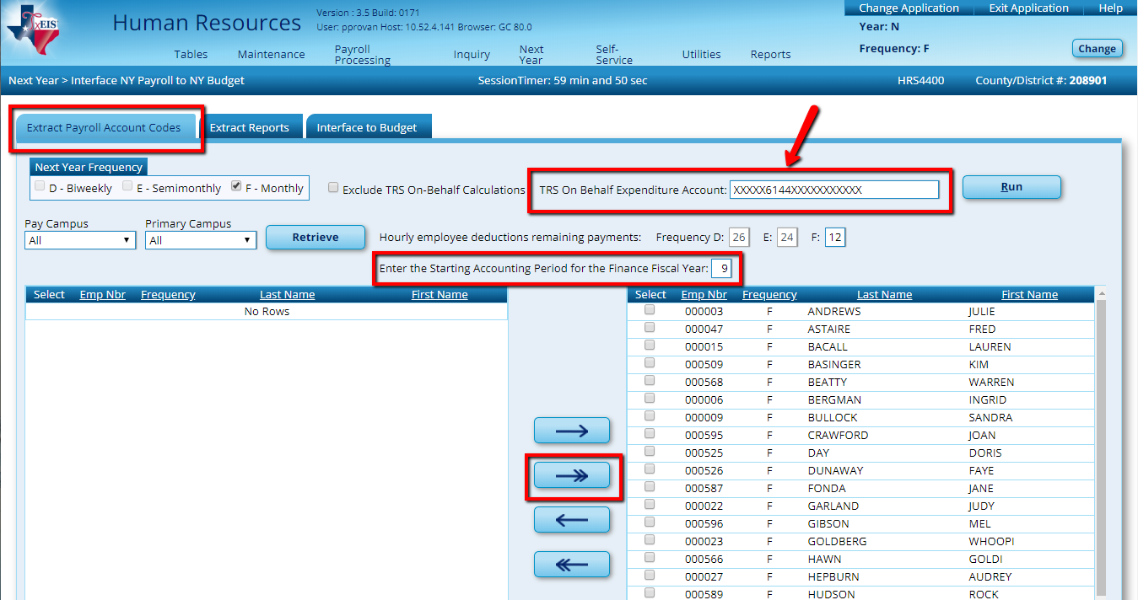

Consider the following:

- Employees who are ‘Inactive’ in Next Year Payroll will not be counted in Budget totals
- Fiscal Year in all employee distributions must be accurate to match with existing Account Codes in Budget. If accounts do not match, an error message will be displayed indicating that the account in HR distributions does not pass validation.
- Once you have extracted and interfaced, amounts will only be over-laid with new figures when account codes match exactly. Therefore, careful consideration should be made to the TRS On Behalf Expenditure Account so that On Behalf is not ‘double-budgeted’ on a subsequent extract and interface. Be sure to use this account code in your Payroll process throughout the year.
- This process can be repeated as often as needed but each time you make changes you must extract the employee account codes again.

At the Preview, review your Failure and Warning Messages. Employees with a Failure will not process at all. Those with Warnings will process, but may not include all of the amounts you desire. You may only Cancel this report. If there are corrections that need to be made, you can do so at this point. If not, proceed to the next step.

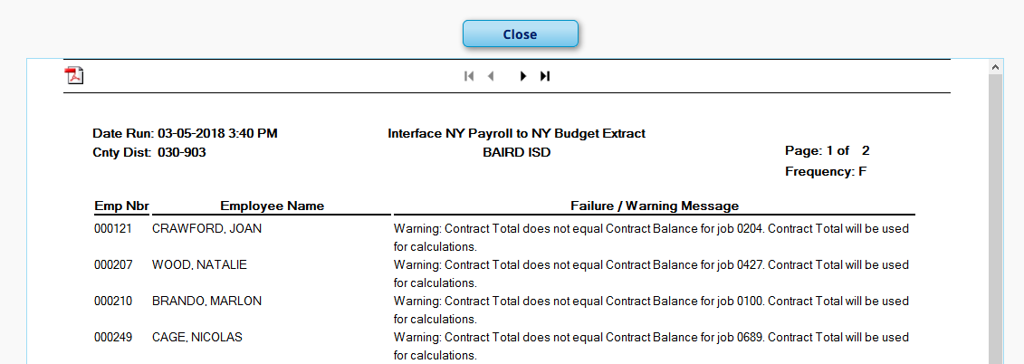

Note: The error displayed above is one we see commonly. The error indicates the Contract Total and Remaining Balance don’t match. This typically occurs because the employee isn’t tied to a pay table and therefore wasn’t updated during the Mass Update Steps. It is a good indication that their pay may not have been updated to the new amount or that when manually updated, only the Contract Total was changed, not the Remaining Balance. We recommend going back and making the needed corrections so your Budget will be more accurate.

_____60. Once extracted, proceed to the Extract Reports tab. Verify both Extract Reports for accuracy. Consider the following:
- All employees needed for budget are on the report.
- Grant Codes, Accrual Codes, and Account Codes are accurate.

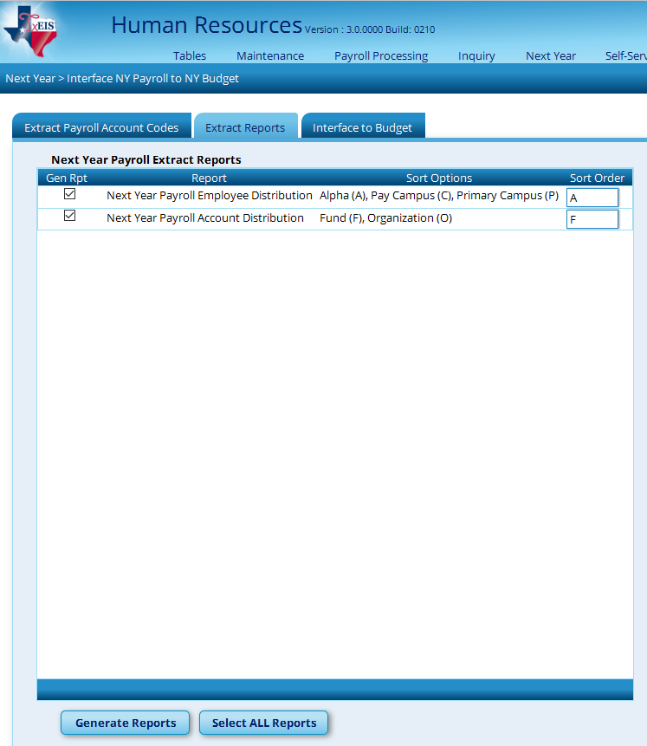

The Next Year Payroll Account Distribution Report will come up immediately after the Next Year Payroll Employee Distribution Report.

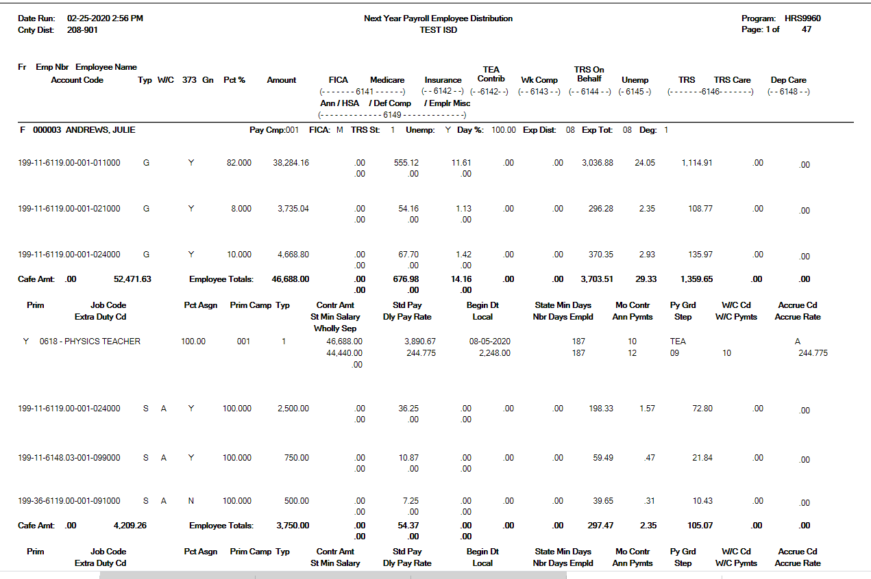

All new employees and/or vacant positions are represented

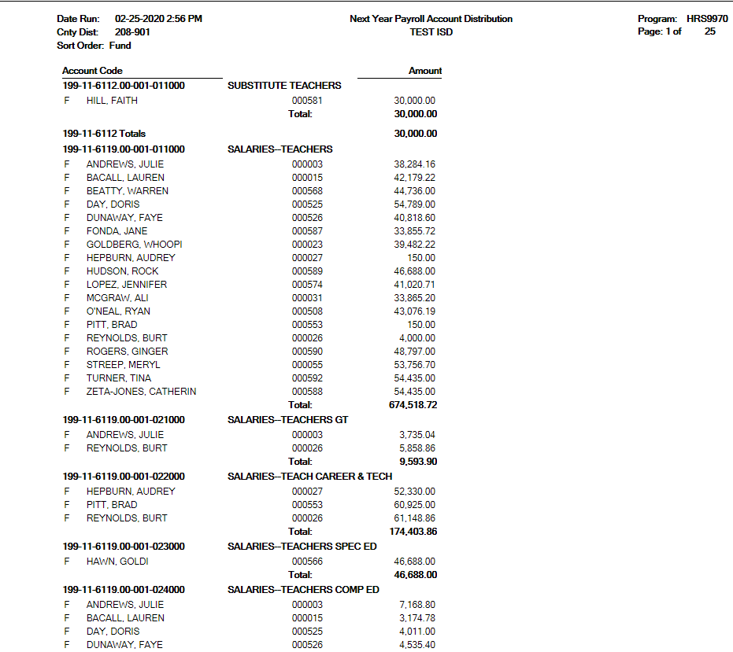

After reviewing reports, make any necessary corrections, re-extract, and re-verify until data is accurate. This can be repeated as often as necessary. If you are going through these steps again after you have already moved some of your employees from NY to Current, remember to re-activate them for this process. Employees are automatically inactivated once they are moved from Next Year to Current. Once you complete the extract and interface in steps 59-61, inactivate those employees again so you don’t accidentally move them over to Current again.

_____61. Interface NY Payroll amounts to Budget from Next Year Payroll > Interface NY Payroll to NY Budget > Interface to Budget.

Note: The interface to Budget process over-writes existing data as long as the accounts match. Keep in mind that if there is not a match, the original accounts that are no longer needed will not be deleted. Example: If you originally budgeted for only one RN coded to 199-33-6119… and then did not hire this position and hired an LVN instead that uses 199-33-6129… then both accounts will be in budget.

Select the Budget tab you wish to see the amounts interfaced to. Select the box to Round account totals to the nearest dollar and select Interface.

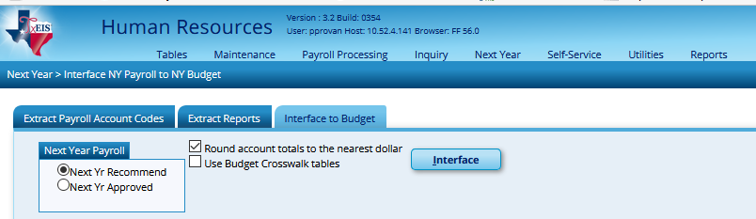

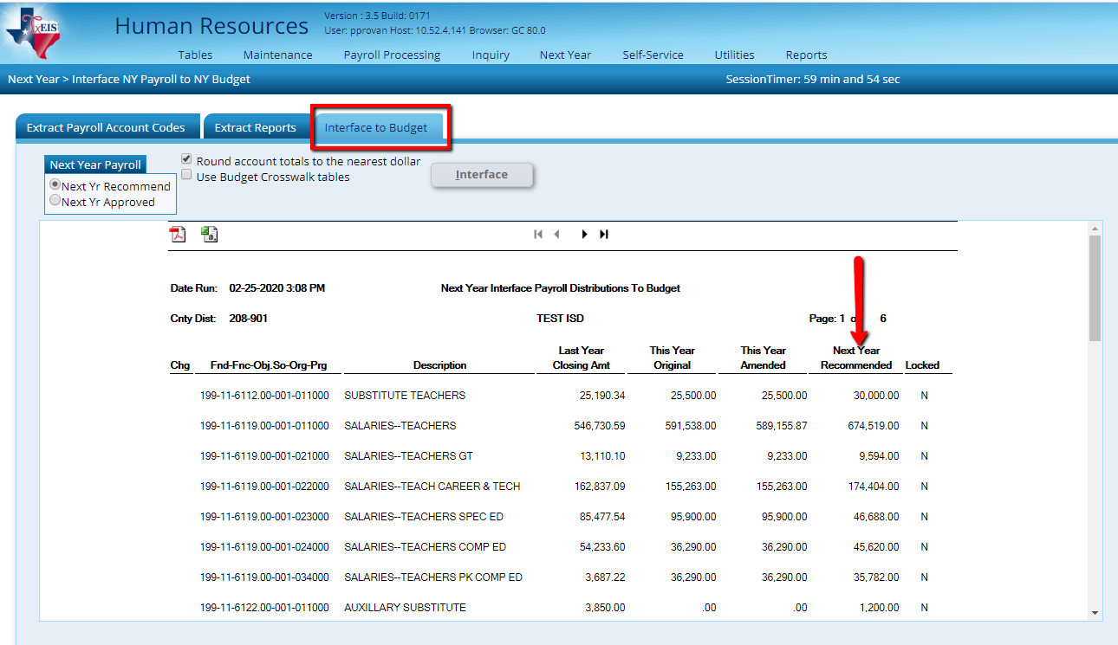

Note: Once Interfaced, consider unemployment table settings. See Step 58.

_____62. Update Staﬀ Credentials

Human Resources > Tables > Credential

Update the following tabs to reﬂect any employee credential changes. This information is used to maintain teacher credentials.
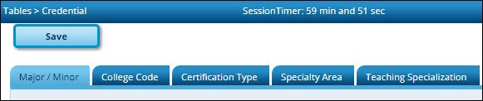
This task is usually done by the personnel department and does not aﬀect salary calculations.

The following credential tabs are shared between the current year and next year records; therefore, changes to the current year records are eﬀective in the next year records, and vice versa.

- Human Resources > Tables > Credential > Major/Minor
- Human Resources > Tables > Credential > College Code
- Human Resources > Tables > Credential > Certiﬁcation Type
- Human Resources > Tables > Credential > Specialty Area
- Human Resources > Tables > Credential > Teaching Specialization

